Our coordinate system was situated so that the z-axis extends out of the nosecone and the x-axis extends to the right. The figure below illustrates the body-fixed coordinate system. The blue bar is positive x, green is positive y, and red is positive z:

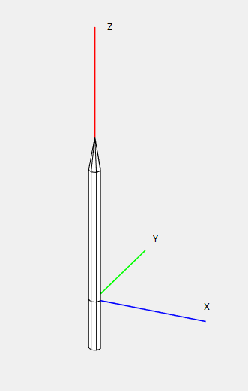

Figure 7 Body-fixed coordinate system